SCO Project – Workflow Guide

Each folder will have its own folder. However instead of the usual format of previous versions, please number every version. Example below:

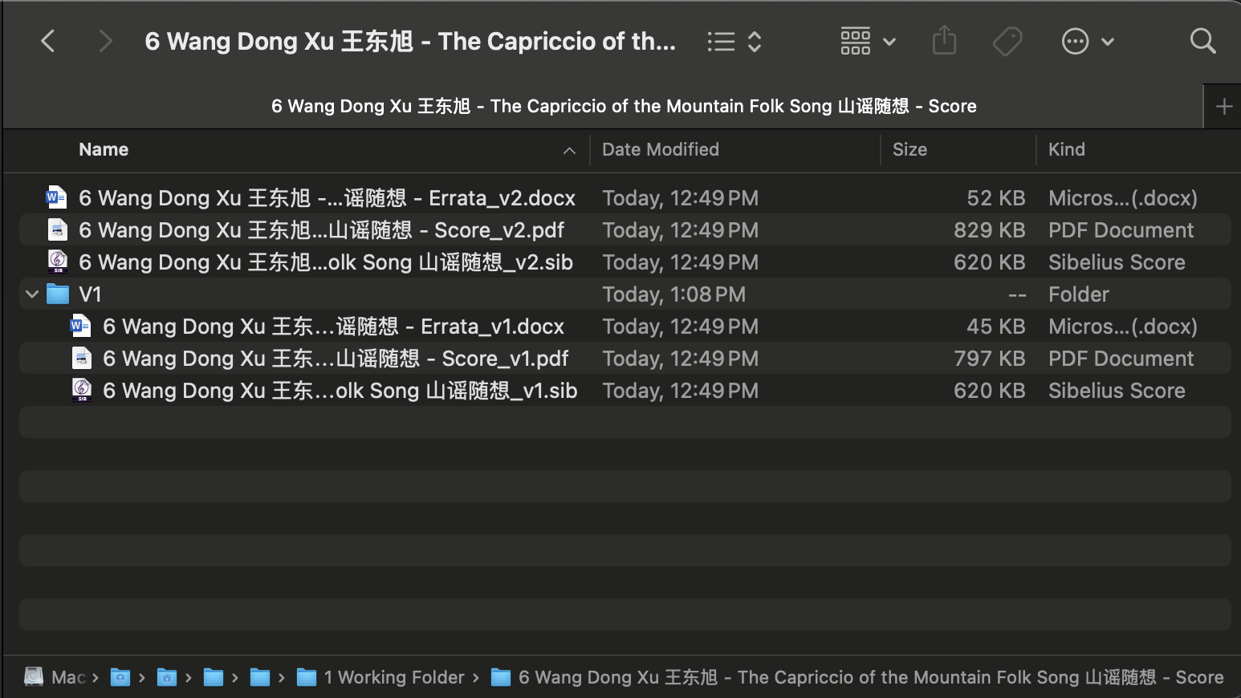
There is no need to create multiple versions for every submit, only make a new version if changes are requested by me or the client after submission. I.e. if tasked to edit ‘Score A’, please make all of your edits, and submit Score A_v1 as Sibelius, PDF and Word Doc Errata List. After my comments, you can then make a new version and called it _v2.

However, please continue to submit on every use and just give a description in your Github submits.

